*Thanks for your support!!*

At the end of the year we received some great donations / partnerships.   
  
We are immensely grateful for these donations because thanks to these donations we can offer the public a better environment to work in with better tools and machines.  
  
So we would like to take this opportunity to thank these companies.

**Universal Lasersystems**,  
for providing this brand new lasercutter with filter system!  
[www.ulsinc.com.tw](http://www.ulsinc.com.tw)

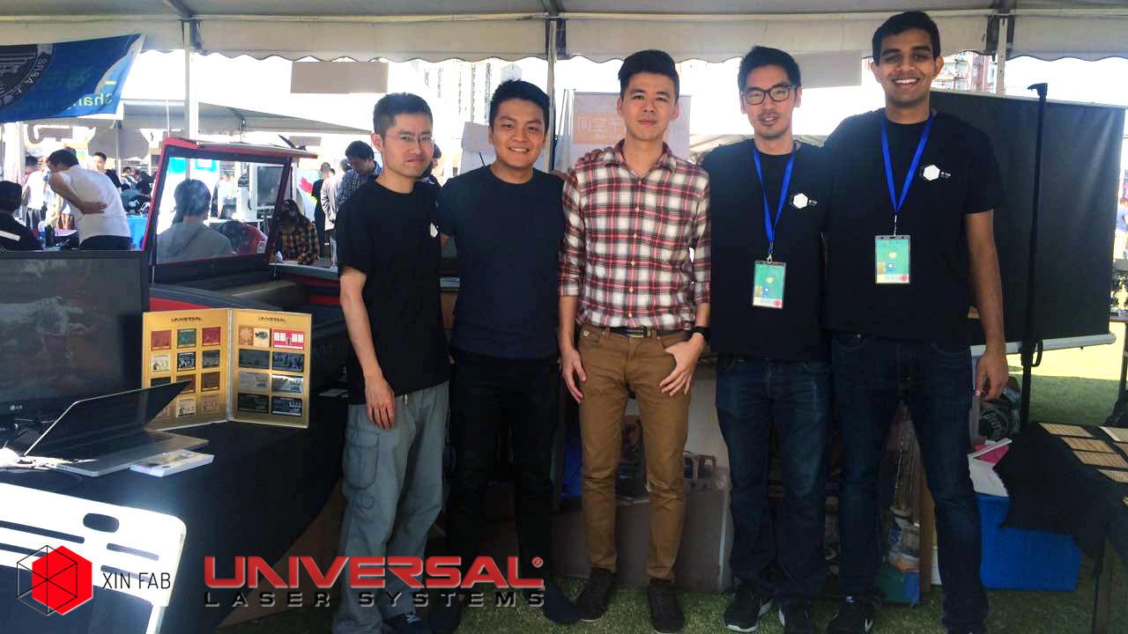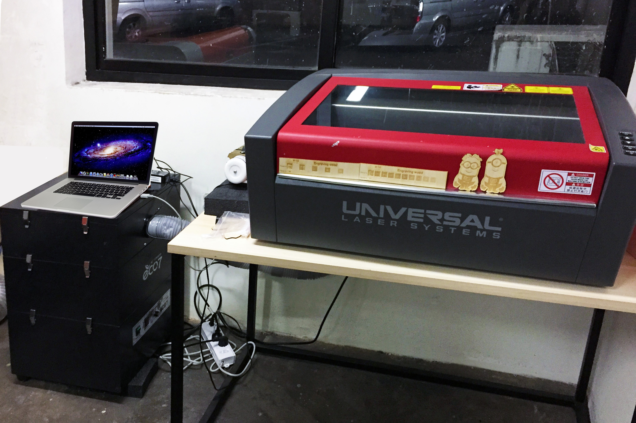  
  
**Adeo,**

for donating this enormous amount of useful hand tools and machines!  
[www.adeo.com](http://www.adeo.com)   
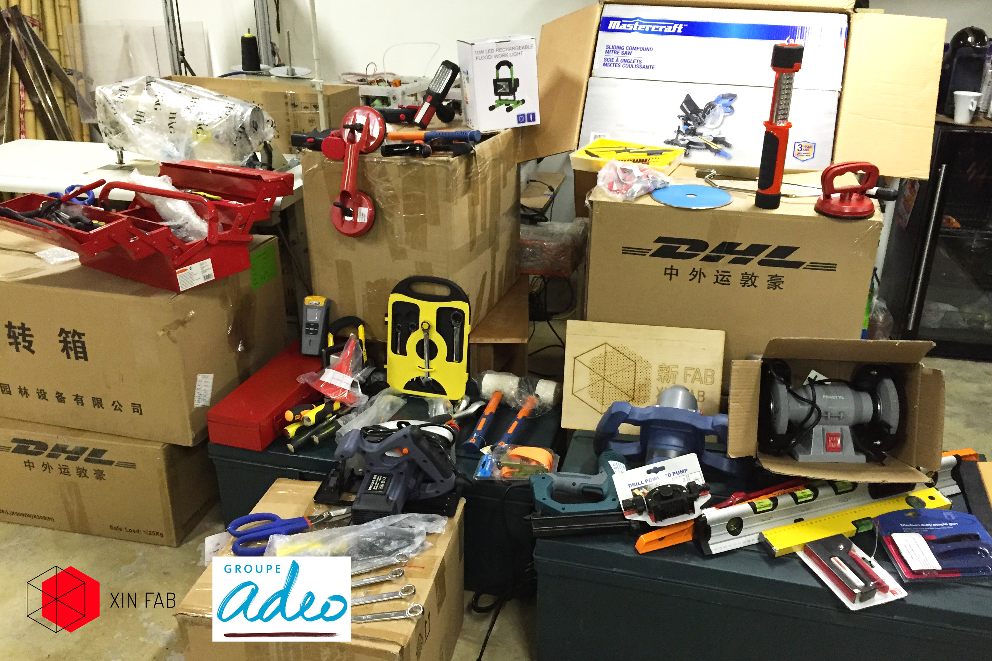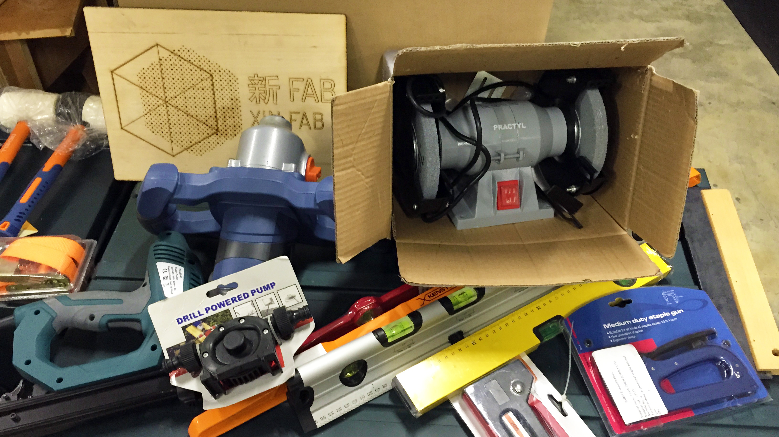

**Scandinavian Business Seating**,  
for donating 6 brand new “Capisco Puls” Office chairs and 4 “RBM Noor” chairs.  
[www.sbseating.com](http://www.sbseating.com)

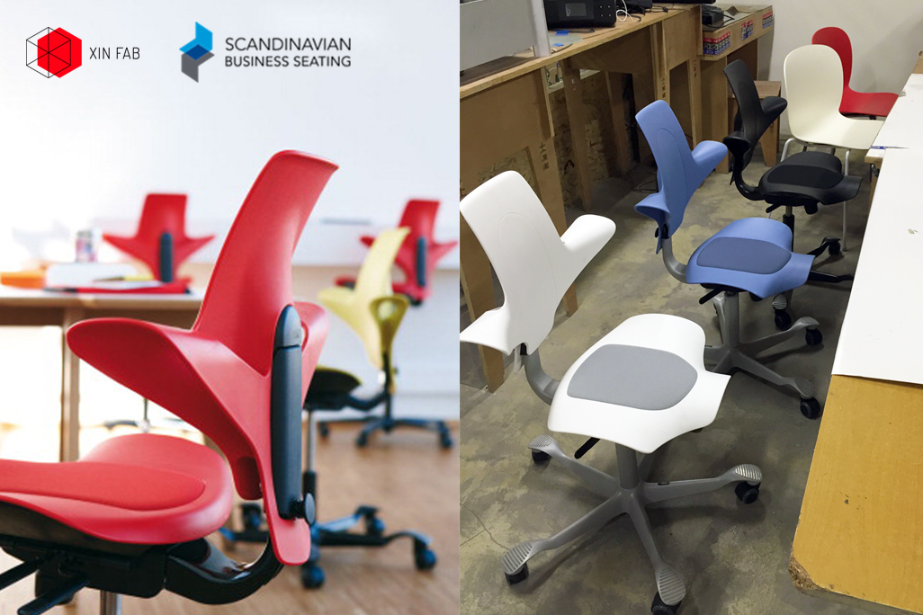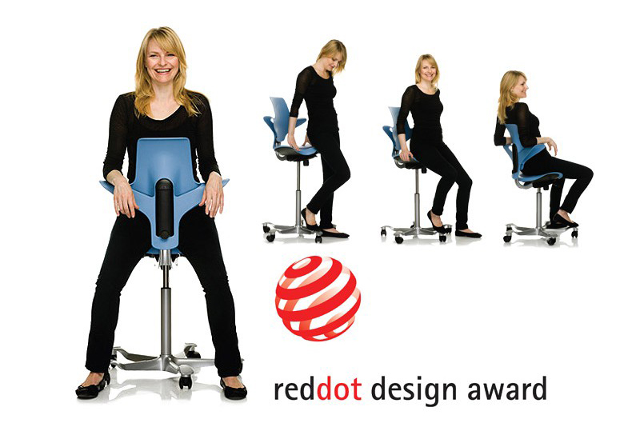

**Motive China**,  
for donating this amazing strong and fast industrial sewing machine.  
[www.motivechina.com](http://www.motivechina.com)

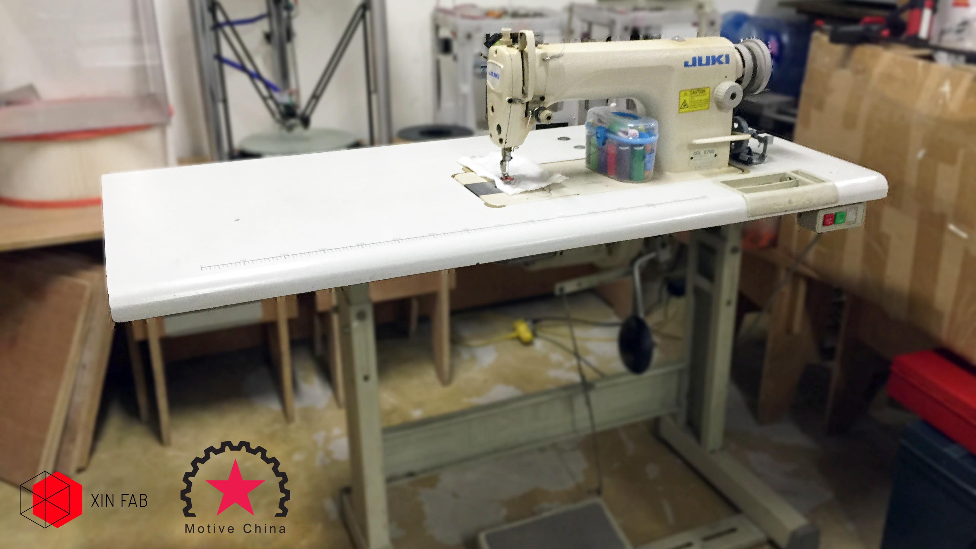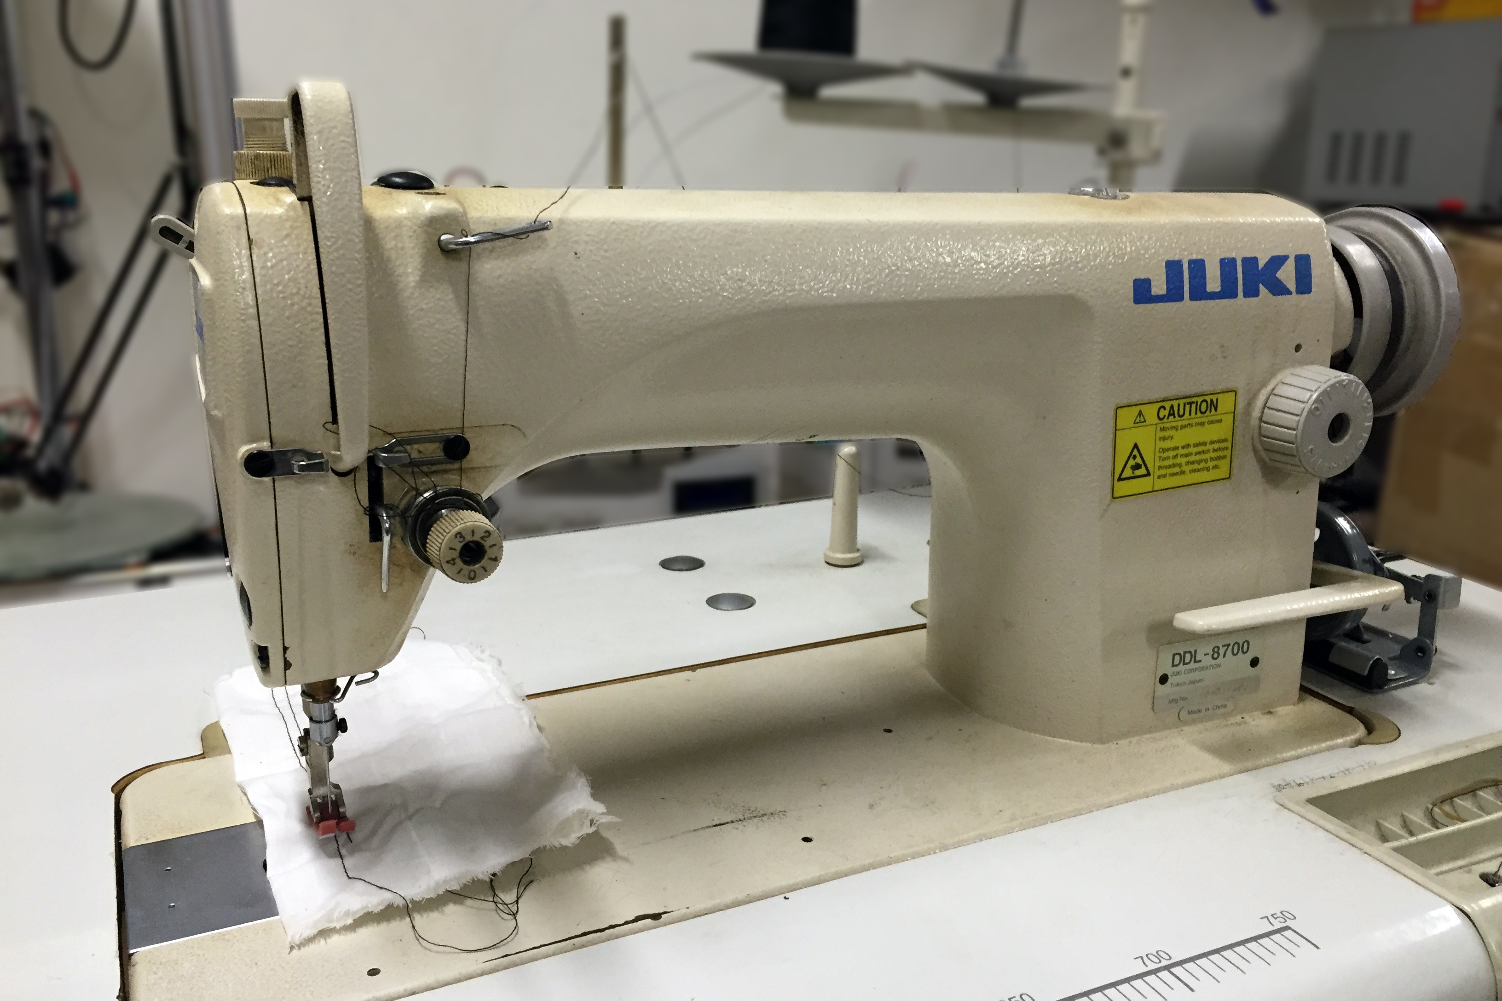

**We are a non profit community and these donations are a necessity for us in order to survive, so if you have anything of value for our space feel free to contact us.**  
  
*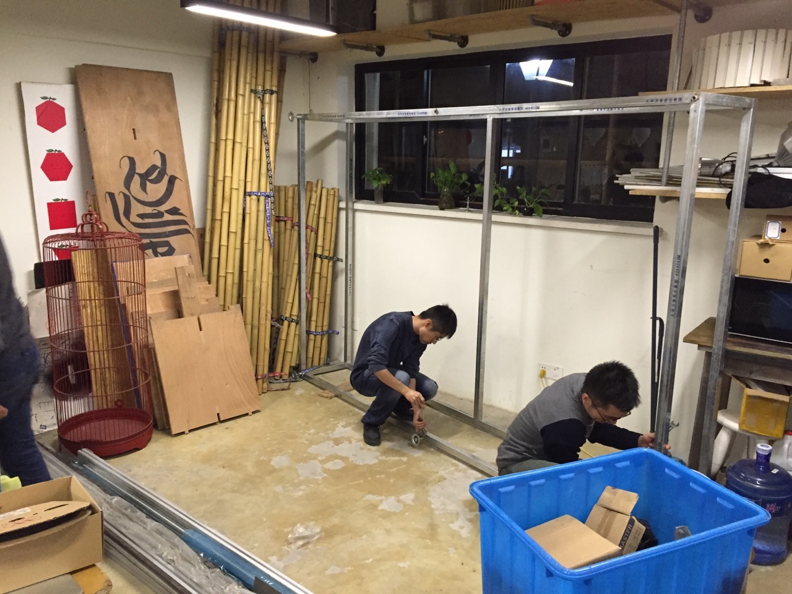For 2015 we are still very seriously looking for partnerships and sponsors for:*   
- Working tables (since our big cnc is gone and we have a big space left now!)  
- Easy to use cnc machine  
- Sandblaster  
- Vacuum forming machine   
- Computer screen  
- Financial support

In exchange we offer promotion of your brand and product in the active maker community of shanghai but also worldwide digital promotion through our website which is also connected to the MIT fablab network, facebook page, meetup page and wechat account.

We look forward hearing from you!! All the best for the New Year!!

**Xinfab team**  
  
*Lucio  
Sean  
Danny  
Eva  
Lufeng  
Simona  
Kris*